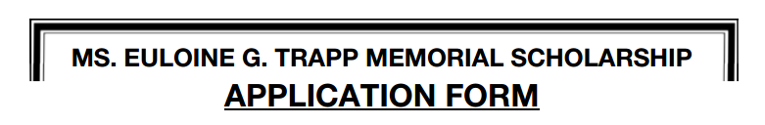
TERMS:
Up to $2,000 in scholarships have been made available for competition among students that:
a) have finished a secondary school program;
and
b) have been accepted in the first year of a full-time post-secondary program at a community college or a university for the fall term in 2018.
and
c) Is participating as a contestant in the 2018 Contest.

JUDGING CRITERIA:
The board of directors will review all entries submitted by the deadline date.
The decision is final.

NOMINATION FORM:
All entries should be typed or printed. Photographs will not be accepted.

AWARD:
Scholarships up to a total amount of $2,000 plus a plaque will be awarded during the finals of the contest on Saturday evening, September 1st, 2028.
The successful applicants will be notified during the contest.

RETURN OF ENTRIES:
All entries become the property of the Pembroke and Area Fiddling Association.

DEADLINE:
All entries must be received no later than 6:00 p.m., August 17th, 2018 at the following address: (No e-mails accepted)
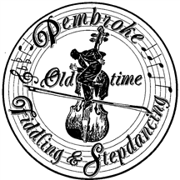
Pembroke & Area Fiddling Association
P.O. Box 1329
Deep River, Ontario K0J 1P0
Attention: Scholarship



Name: ___________________________________________________________________
Address: ___________________________________________________________________
___________________________________________________________________
___________________________________________________________________
Telephone No.: ______________________ E-Mail: ___________________________________
Date of Birth: __________________________________________________________________

High School Transcript: An original copy of your High School Transcript showing courses, level and marks must accompany this form.

Proof of acceptance at a Post-Secondary Institution: A copy of a letter or e-mail indicating acceptance in the first year of a program in a Post-Secondary Institution for the fall term of 2018, must accompany this form.

Other relevant information:
- In which categories are you competing in the 2018 Contest?
___________________________________________ ___________________________________________
___________________________________________ ___________________________________________
- In what year did you first compete in the Pembroke Contest? ________________________
- In what year did you last compete in the Pembroke Contest? ________________________
- In what other contests have you competed in the past five years other than the Pembroke Contest?
____________________________ ____________________________ _____________________________
____________________________ ____________________________ _____________________________
____________________________ ____________________________ _____________________________
____________________________ ____________________________ _____________________________
____________________________ ____________________________ _____________________________
5. Why do you feel that you deserve The Euloine G. Trapp Memorial Scholarship?
(In 100 words or less).
________________________________________________________________________________________________________________________________________________________________________________________________________________________________________________________________________________________________________________________________________________________________________

SIGNED: ____________________________________ DATE: ____________________________
(use another page, if necessary)

